Project Development Phase Model Performance Test

Date | 12 September 2026
Project Name | Employee Raise Issue
Maximum Marks

Model Performance Testing:
The project developer shall fill the following information in the Model Performance Testing Template.

S.No. | Parameter | Values | Screenshot
1. | Model Summary | ServiceNow automation for employee issue management using Record Producer, Custom Table, Fields, Flow Designer,  Notifications, and Reports. | 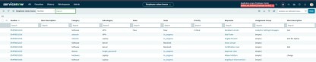
2. | Functional Accuracy | Employee issues are created successfully, mandatory fields are validated, and records are stored  correctly in the table. | 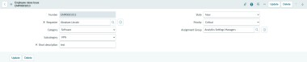
3. | Filter & Report Validation | Records are successfully filtered using State = Accepted, Category, and Priority. The report displays the correct records. | 

